St. Anna Greek Orthodox Church
Epiphany House Blessing Form, 2017
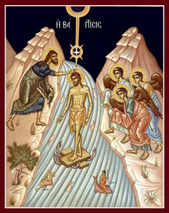
During the weeks following the Feast of Theophany (The appearance of the Holy Trinity at Christ’s Baptism – Celebrated January 6th), it is customary for the Parish Priest to bless the homes of his parishioners with Holy Water from the Great Sanctification of the Waters, asking the Lord to grant peace, health, salvation and protection to the home, and to the family who resides there. It is also appropriate, during this special time, to have your businesses blessed at this time as well.
Name_________________________________________________________
Address________________________________________________________
Best Phone Number______________________________________________
Preferred Date(s)_________________________________________________
Check Desired Time Slot: Morning__Early Afternoon___Late Afternoon__Early Evening___
Please mail, email or return this form to the church before the end of January so that Fr. Anthony can properly schedule and accommodate the needs of our parishioners. House Blessings will continue until February 26th, 2017. This is a wonderful opportunity for Fr. Anthony to get to know you and your family in the comfortable environment of your own home. This is the best occasion to share with your priest, your thoughts and dreams concerning our parish community.
Upon Fr. Anthony’s arrival, please have the family ready to begin the blessing service. Lights should be turned on in all the rooms of the house that are to be blessed. Please provide a list of all names of family members who live in the house so that he can properly pray for them. Please make sure that all televisions, radios and computers are off at the time of the Blessing. Once this form is received, Fr. Anthony will call to finalize a specific time to bless your home. God bless!
Glory to the Triune God Who Reveals Himself upon the Waters of the Jordan!

